

Development since 2005: Sub-Saharan Africa, South Asia, Latin America and East Asia

Summary
South Asia made the most progress since 2005, followed by East Asia, Sub-Saharan Africa and Latin America, based on GDP per capita, life expectancy and secondary school enrollment from the World Bank, with UN population context.

Summary and ranking
Ranking on progress since 2005: 1. South Asia, 2. East Asia, 3. Sub-Saharan Africa, 4. Latin America. The ranking averages standardised gains in three World Bank indicators between 2005 and 2023, the latest year with data for all four regions [1]. South Asia led because it improved on all three measures at once: GDP per capita grew 134%, life expectancy rose 7.2 years, and secondary enrollment rose 23 points. East Asia had the largest income gain in absolute dollars, but its life-expectancy gain is smaller than the world's. Sub-Saharan Africa made the biggest health gain and the smallest income gain. Latin America started highest and gained least on every measure.
FASTEST INCOME GROWTH  South Asia +134%  GDP per capita, constant 2015 US$, $940 → $2,201; World +35% [1] | BIGGEST HEALTH GAIN  Sub-Saharan Africa +8.7 yrs  Life expectancy 53.9 → 62.6; World +4.2 yrs [1] | BIGGEST SCHOOLING GAIN  South Asia +23.0 pts  Gross secondary enrollment 54.9% → 77.9%; East Asia was close at +21.6 pts [1]
WEAKEST INCOME TREND
Sub-Saharan Africa +15%
GDP per capita fell from $1,623 in 2019 to $1,571 in 2023 [1]

Progress since 2005, ranked
Progress score is the average of the three gains after each is standardised across the four regions (mean 0, so negative means below the four-region average). The score is relative to these four regions only, not an absolute measure. Gains cover 2005–2023. [1]
Rank | Region | GDP per capita change | Life expectancy gain (years) | Secondary enrollment gain (pts) | Progress score
1 | South Asia | +134% | +7.2 | +23.0 | +1.00
2 | East Asia | +107% | +3.4 | +21.6 | +0.21
3 | Sub-Saharan Africa | +15% | +8.7 | +14.4 | -0.13
4 | Latin America | +22% | +3.1 | +10.9 | -1.09
– | World (reference) | +35% | +4.2 | +12.8 | –
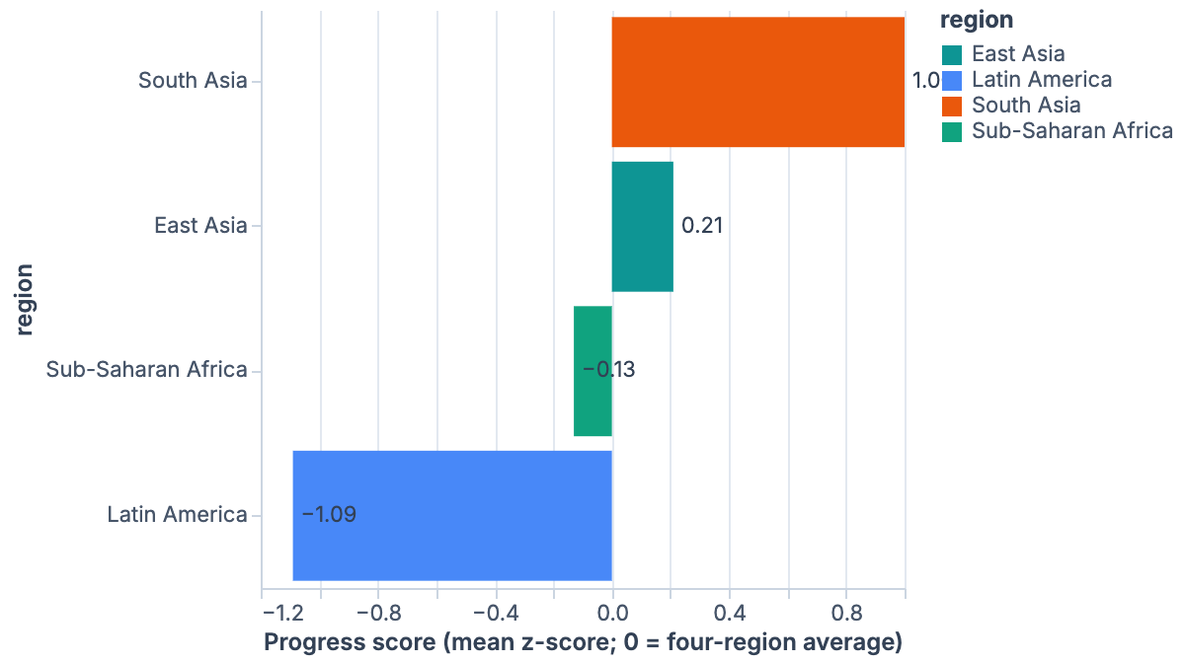
Progress score by region. South Asia leads by a wide margin; Latin America trails. [1]

How robust is the order?
Note: South Asia is first and Latin America is last under every variant tested except one (GDP as an absolute dollar gain puts East Asia first and South Asia second). The middle two places are less secure. East Asia and Sub-Saharan Africa swap if either GDP or secondary enrollment is dropped from the score. The test table on the Method page lists every variant.

Side-by-side comparison
Three things separate the regions: where they started, how fast they moved, and whether the gap to the world average closed. South Asia and East Asia pulled away from the other two on income. Sub-Saharan Africa gained fastest on health but is still far behind on all three measures. Latin America stays ahead of the world on health and schooling, but its lead has narrowed on all three measures.
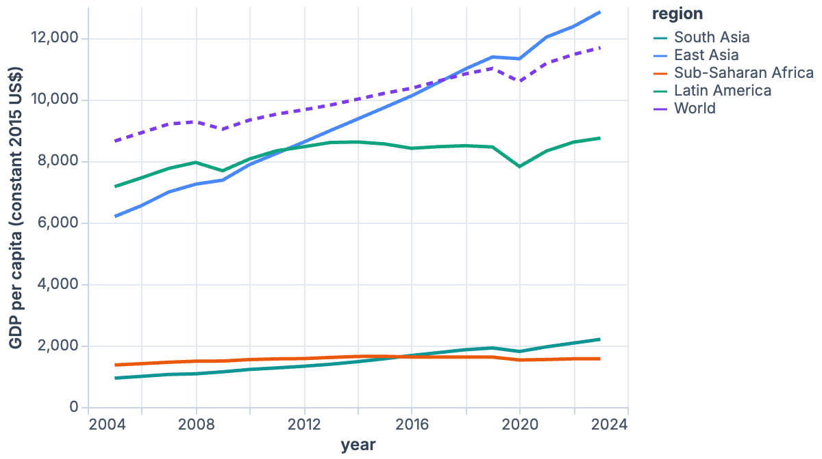
GDP per capita, 2005–2023. East Asia (World Bank East Asia & Pacific) overtook the World average in 2018; Latin America lost ground against it. [1]
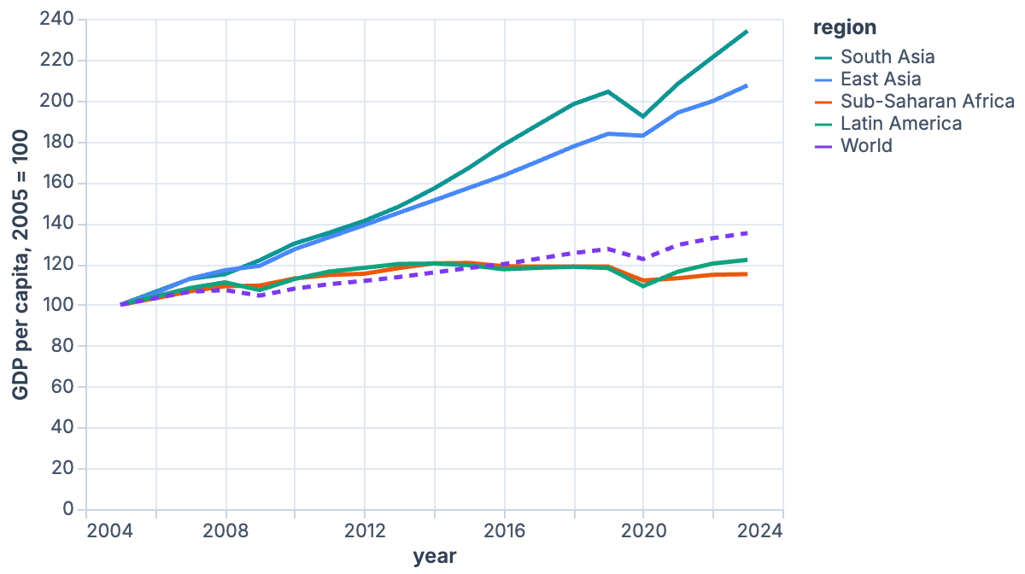
The same series indexed to 2005 = 100, which shows growth regardless of starting level. Sub-Saharan Africa's index stays near 100–125 while South Asia passes 230. [1]
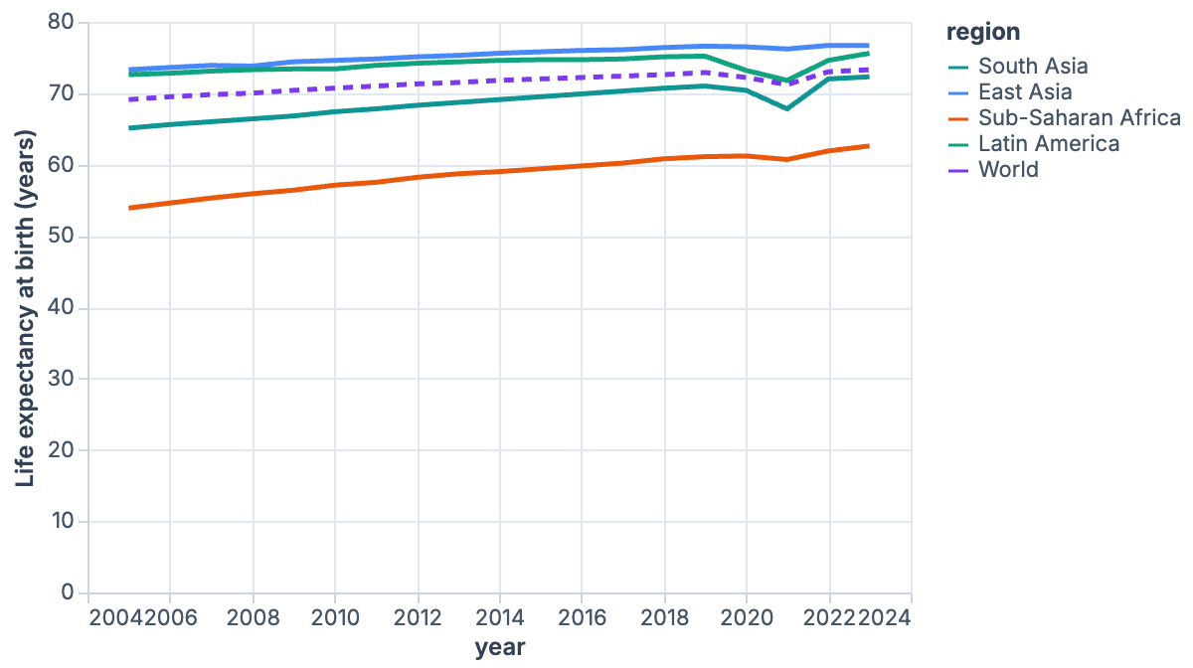
Life expectancy, 2005–2023. The dip in 2020–21 is visible in South Asia and Latin America. [1]
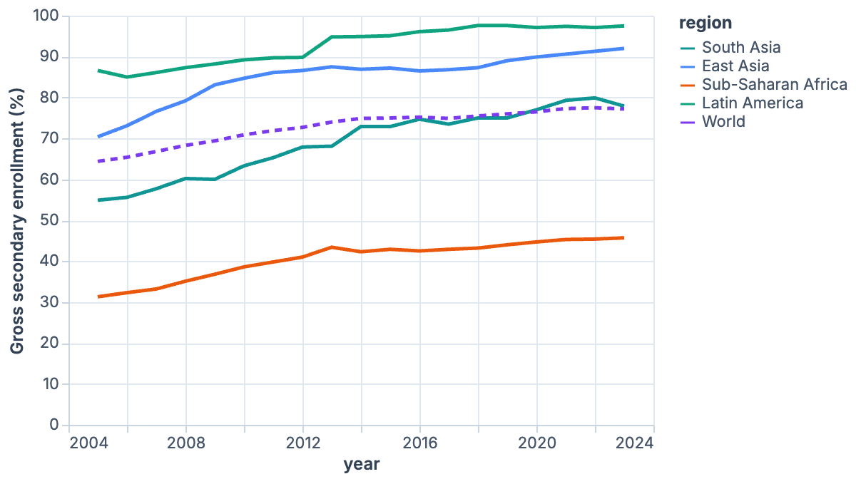
Gross secondary school enrollment. Gross ratios can exceed 100% because they count over-age and under-age pupils. [1]

Levels, 2005 → 2023
World Bank regional aggregates: SAS, EAS, SSF, LCN and WLD. [1]
Region | GDP per capita (constant 2015 US$) | Life expectancy (years) | Secondary enrollment (% gross)
South Asia | $940 → $2,201 | 65.1 → 72.3 | 54.9% → 77.9%
East Asia | $6,191 → $12,839 | 73.3 → 76.7 | 70.4% → 92.0%
Sub-Saharan Africa | $1,367 → $1,571 | 53.9 → 62.6 | 31.3% → 45.7%
Latin America | $7,161 → $8,736 | 72.6 → 75.6 | 86.6% → 97.5%
World | $8,639 → $11,671 | 69.1 → 73.3 | 64.4% → 77.2%

Pace of gain relative to the world
Each region's 2005–2023 gain divided by the World's gain on the same measure. Above 1.0× means the region improved faster than the world. [1]
Region | GDP per capita growth vs World | Life expectancy gain vs World | Secondary enrollment gain vs World
South Asia | 3.8× | 1.7× | 1.8×
East Asia | 3.1× | 0.8× | 1.7×
Sub-Saharan Africa | 0.4× | 2.1× | 1.1×
Latin America | 0.6× | 0.7× | 0.9×
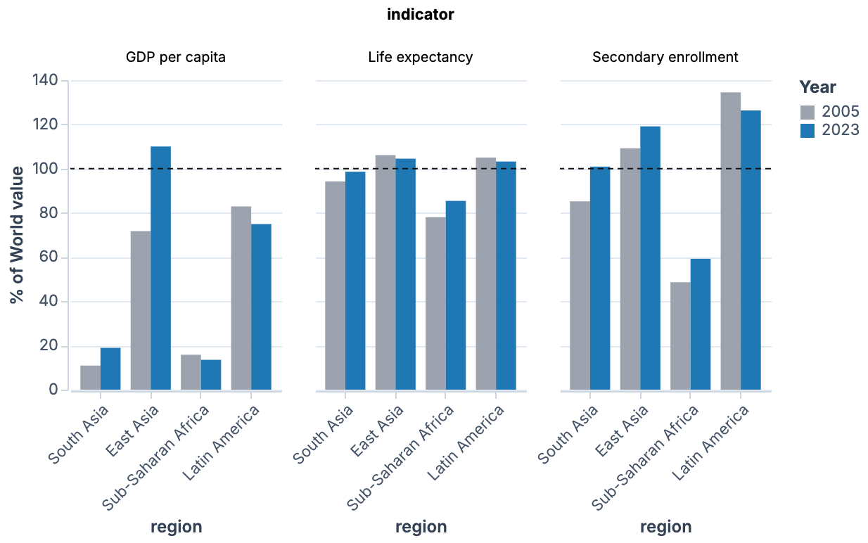
Each region as a percentage of the World value, in 2005 (grey) and 2023 (blue). The dashed line is parity with the world. South Asia crossed parity on secondary enrollment; Sub-Saharan Africa and Latin America moved away from parity on income. [1]

Population and demographics (UN), 2005 → 2023
UN World Population Prospects 2024, median variant, estimates. UN regions differ slightly from World Bank regions: UN Southern Asia includes Iran, and UN Eastern and South-Eastern Asia excludes Pacific islands. [2][3]
Region | Population (millions) | Fertility (births per woman) | Median age (years) | Dependency ratio (per 100 aged 15–64)
South Asia | 1,619 → 2,043 | 3.07 → 2.22 | 21.5 → 26.8 | 63.8 → 50.6
East Asia | 2,107 → 2,350 | 1.80 → 1.33 | 30.5 → 37.0 | 43.8 → 46.5
Sub-Saharan Africa | 750 → 1,212 | 5.56 → 4.32 | 16.6 → 18.1 | 89.3 → 79.2
Latin America | 556 → 659 | 2.34 → 1.81 | 24.7 → 30.9 | 56.2 → 48.0
World | 6,587 → 8,092 | 2.63 → 2.25 | 26.1 → 30.4 | 55.6 → 53.9

What the demographics add
Sub-Saharan Africa added about 462 million people (+62%), almost three times the world's growth rate, which helps explain its weak income per head [2]. East Asia is the only region where the dependency ratio rose (43.8 to 46.5 per 100), because it is ageing and its fertility rate, 1.33 births per woman, is well below the world's 2.25 [2][3]. South Asia's dependency ratio fell by 13 points, to below the world's. This is the demographic dividend that tends to accompany faster income growth.

South Asia
Rank 1. South Asia had the strongest all-round progress. It grew fastest on income, led on schooling gains, and closed most of its gaps to the world average.
BIGGEST GAIN  GDP per capita +134%  $940 → $2,201, 3.8× the World's growth of 35% [1] | BIGGEST GAP  GDP per capita: 18.9% of World  Up from 10.9% in 2005, so the relative gap narrowed [1] | SCHOOLING  Secondary enrollment 77.9%  Overtook the World's 77.2%, from 85% of World in 2005 [1]
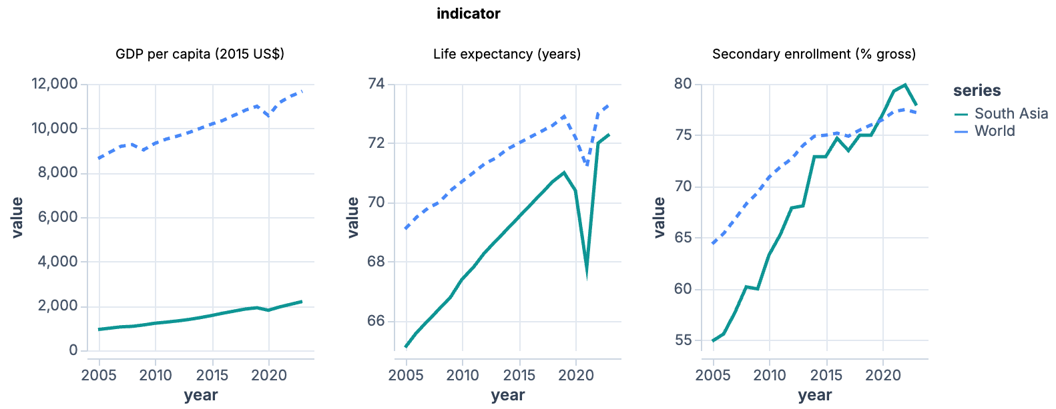
South Asia (solid) against the World aggregate (dashed), 2005–2023. Each panel has its own vertical scale, so compare the gap between the two lines within a panel. [1]
South Asia's income gain is the largest relative gain in the four regions, and it also made large health and schooling gains: life expectancy rose 7.2 years to 72.3, 98.6% of the world level [1]. The gap that remains is income. GDP per capita is only 18.9% of the world's, and in absolute dollars the gap widened, from about $7,700 to $9,500, because the world started from a higher base [1]. Growth also slowed: 5.3% a year from 2005 to 2015 and 4.3% from 2015 to 2023 [1]. Life expectancy fell to 67.8 years in 2021 before recovering to 72.3 [1].
Note: The UN's Southern Asia region (id 5501) includes Iran; the World Bank's South Asia does not. UN demographic figures for South Asia are therefore slightly older and lower-fertility than the World Bank boundary implies [2].

East Asia
Rank 2. East Asia is the only one of the four regions that is already ahead of the world on all three measures, and it started ahead.
BIGGEST GAIN  GDP per capita +107%  $6,191 → $12,839, the largest dollar gain (6,648), 3.1× World growth [1] | BIGGEST GAP  Life expectancy: 104.5% of World  Closest to the world on this measure; the lead fell from 106.1% in 2005 [1] | DEMOGRAPHIC STRAIN  Fertility 1.33  Dependency ratio rose 43.8 → 46.5, the only region where it rose [2][3]
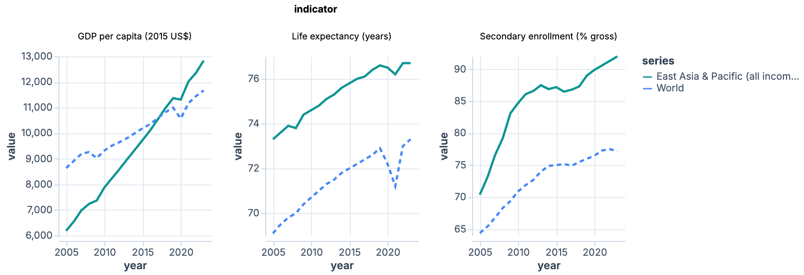
East Asia (World Bank East Asia & Pacific) (solid) against the World aggregate (dashed), 2005–2023. Each panel has its own vertical scale, so compare the gap between the two lines within a panel. [1]
East Asia has no deficit to name against the world, so its "gap" is the measure where its lead is thinnest. That is life expectancy: it gained 3.4 years, below the world's 4.2, so its lead over the world shrank. East Asia's other weak spot is demographic: low fertility and an ageing population [2]. Its income growth slowed after 2015 (4.6% a year before, 3.5% since) but stayed double the world's pace [1]. The "East Asia & Pacific" aggregate includes high-income economies such as Japan, Korea and Australia. Its low- and middle-income subset (EAP) shows an even bigger income jump, +212%, and a life-expectancy gain of 3.5 years [4].
Warning: The choice of East Asia boundary matters for the ranking. Using EAP (excluding high income) instead of EAS puts East Asia ahead of South Asia when ranks are averaged, though not on the z-score. The UN demographic series for East Asia covers Eastern and South-Eastern Asia (id 1832), which differs from both World Bank definitions [2].

Sub-Saharan Africa
Rank 3. Sub-Saharan Africa made the biggest health gain of any region but the smallest income gain, and it started furthest behind on all three measures.
BIGGEST GAIN  Life expectancy +8.7 years  53.9 → 62.6, 2.1× the World's gain of 4.2 years [1] | BIGGEST GAP  GDP per capita: 13.5% of World  $1,571 against $11,671; down from 15.8% in 2005, so the gap widened [1] | POPULATION  +462 million  +62% since 2005; fertility still 4.32 births per woman [2]
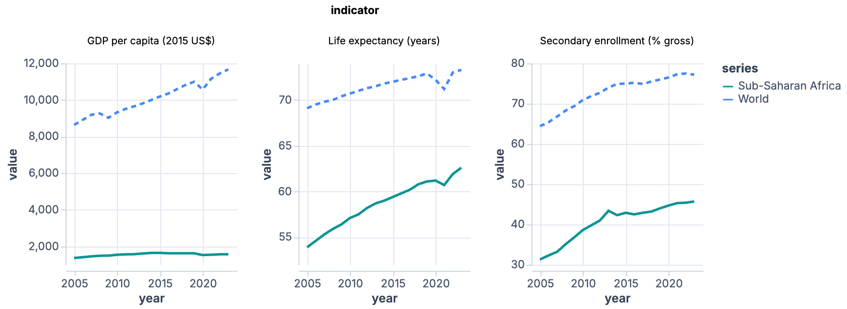
Sub-Saharan Africa (solid) against the World aggregate (dashed), 2005–2023. Each panel has its own vertical scale, so compare the gap between the two lines within a panel. [1]
Life expectancy rose from 78% to 85% of the world level, the fastest convergence in any region [1]. Secondary enrollment also rose 14.4 points, a little faster than the world's gain, but only to 45.7%, which is 59% of the world value [1]. Income is the problem. GDP per capita grew only 15% in 18 years, from $1,367 to $1,571 (0.8% a year), and fell between 2019 and 2023 [1]. Population grew 62% over the same period, so total output has had to grow much faster than output per head just to keep income per person rising [2]. In PPP terms the picture is similar: +18% against +45% for the world [1].
Note: The teammate run described the World Bank SSF aggregate as excluding high-income economies. World Bank metadata names SSF as "Sub-Saharan Africa" with no income exclusion, so it is comparable to the UN region 947 [5].

Latin America
Rank 4. Latin America started highest of the four developing regions and moved least on all three measures, so it has lost ground against the world.
BIGGEST GAIN (RELATIVE)  Secondary enrollment +10.9 pts  86.6% → 97.5%, but only 0.85× the World's gain of 12.8 pts; no measure outpaced the world [1] | BIGGEST GAP  GDP per capita: 74.9% of World  Down from 82.9% in 2005, so the gap widened [1] | INCOME GROWTH  +22%  1.1% a year against the World's 1.7%; 0.3% a year since 2015 [1]
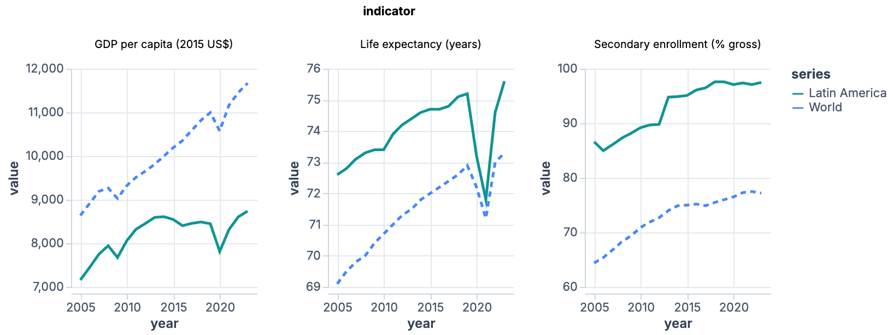
Latin America and the Caribbean (solid) against the World aggregate (dashed), 2005–2023. Each panel has its own vertical scale, so compare the gap between the two lines within a panel. [1]
Latin America is still ahead of the world on life expectancy (75.6 years, 103% of the world) and secondary enrollment (97.5%, 126%), but its lead on each measure is narrower than in 2005 [1]. Income is the weak point. GDP per capita has crawled up since 2015, at 0.3% a year, against 1.7% for the world [1]. Life expectancy fell to 71.8 years in 2021 and recovered to 75.6 in 2023 [1]. The earlier team summary called GDP the region's biggest gain because the dollar change was large, but the region grew by less than the world on GDP, so no measure is a gain in relative terms. Secondary enrollment is the best of the three.

Method and robustness

Method
Each region is a World Bank aggregate (South Asia SAS; East Asia & Pacific EAS; Sub-Saharan Africa SSF; Latin America & Caribbean LCN), compared with the World aggregate WLD [1][5]. Each indicator is measured from 2005 to 2023: GDP per capita (constant 2015 US$) as percentage growth, life expectancy as years gained, and gross secondary enrollment as percentage points gained. The three gains are standardised across the four regions and averaged with equal weights. UN World Population Prospects 2024 supplies population, fertility, median age and dependency ratio [2][3].
The regional analyses were produced by two teammates working in parallel on separate regions, and they were reconciled here. This step re-ran every figure from the combined dataset and re-fetched the dependency ratio, which two files had polluted with multiple age definitions. The East Asia & Pacific (excluding high income) series was fetched separately [4]. Teammates defined "biggest gain" differently (relative to world pace, or in dollars). This report uses one rule for all four regions: the gain measured against the world's gain on the same measure.

Ranking robustness
Rank (1 = most progress) under alternative scoring choices. Rows that differ from the baseline are the East Asia = EAP rank average, the two drop-one variants that omit GDP or secondary enrollment, and absolute GDP gain. [1][4]
Variant | South Asia | East Asia | Sub-Saharan Africa | Latin America
Baseline: mean z-score of three gains | 1 | 2 | 3 | 4
Mean of three indicator ranks | 1 | 2 | 3 | 4
GDP in PPP terms instead of constant US$ | 1 | 2 | 3 | 4
East Asia = EAP (excluding high income) | 1 | 2 | 3 | 4
East Asia = EAP, mean of ranks | 2 | 1 | 3 | 4
Without GDP per capita | 1 | 3 | 2 | 4
Without life expectancy | 1 | 2 | 3 | 4
Without secondary enrollment | 1 | 3 | 2 | 4
GDP as absolute $ gain | 2 | 1 | 3 | 4
End year 2019 (pre-COVID) | 1 | 2 | 3 | 4

Caveats
Warning: Regional aggregates hide large differences between countries (India within South Asia, China and Japan within East Asia). Gross enrollment ratios exceed 100% in some regions and measure access, not learning. Primary enrollment is near saturation, so it is left out of the score. GDP per capita in constant US$ and in PPP give the same order. 2023 is the last year with complete data, and 2020–21 life expectancy was depressed by the pandemic. Using 2019 as the end year does not change the order. Tertiary enrollment was fetched but left out because Sub-Saharan Africa's series ends in 2021.

Dataset
The accompanying dataset holds every series used: the four regions, the World benchmark, and the alternative East Asia definitions, with World Bank and UN rows tagged by region definition.

Sources and Citations
[1] World Bank. World Development Indicators: NY.GDP.PCAP.KD, NY.GDP.PCAP.PP.KD, SP.DYN.LE00.IN, SE.SEC.ENRR, SE.PRM.ENRR for SAS, EAS, SSF, LCN and WLD, 2005–2023.
https://api.worldbank.org/v2/country/EAS/indicator/NY.GDP.PCAP.KD
[2] United Nations, DESA, Population Division. World Population Prospects 2024: total population, fertility rate, median age (Median variant, estimates 2005–2023) for locations 904, 947, 5501, 1832 and 900.
https://population.un.org/dataportalapi/api/v1/data/indicators/49/locations/904/start/2005/end/2023
[3] United Nations, DESA, Population Division. World Population Prospects 2024: total dependency ratio, age definition 0-14 and 65+ per 15-64, locations 904, 1832 and 900.
https://population.un.org/dataportalapi/api/v1/data/indicators/86/locations/904,1832,900/start/2005/end/2023 (accessed October 18, 2026)
[4] World Bank. World Development Indicators for EAP (East Asia & Pacific, excluding high income), 2005–2023.
https://api.worldbank.org/v2/country/EAP/indicator/NY.GDP.PCAP.KD (accessed October 18, 2026)
[5] World Bank. Country and aggregate metadata for SSF, SAS, LCN, LAC, EAS, EAP and WLD.
https://api.worldbank.org/v2/country/SSF;SAS;LCN;LAC;EAS;EAP;WLD (accessed October 18, 2026)

Data Provenance
Each entry records the request behind a numbered reference: when it was fetched, whether the response was live or cached, and a fingerprint (hash prefix) of the response body, so every cited figure can be re-fetched and verified.
[3] UN DESA, WPP 2024 dependency ratio — fetched 2026-10-18 06:35:51 UTC · live response · fingerprint 61fffe8a3107d620
GET https://population.un.org/dataportalapi/api/v1/data/indicators/86/locations/904,1832,900/start/2005/end/2023
[4] World Bank WDI, East Asia & Pacific (excl. high income) — fetched 2026-10-18 06:35:28 UTC · live response · fingerprint b119a3d490cd0de4
GET https://api.worldbank.org/v2/country/EAP/indicator/NY.GDP.PCAP.KD
[5] World Bank region definitions — fetched 2026-10-18 06:36:14 UTC · live response · fingerprint c6e3ededf96267cf
GET https://api.worldbank.org/v2/country/SSF;SAS;LCN;LAC;EAS;EAP;WLD

